35.6: a) The brightest wavelengths are when constructive interference occurs:
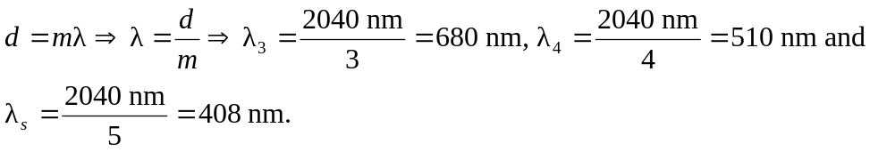
b) The path-length difference is the same, so the wavelengths are the same as part (a).

